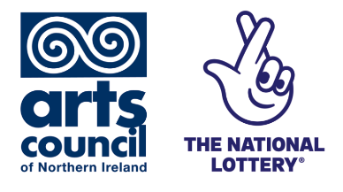
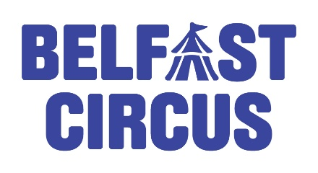
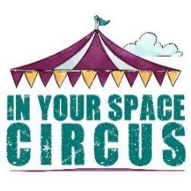
Mike Moloney Award
2026

Programme description:
This programme has been developed to support the progression of young circus and street theatre artists, whether they want to progress into performance, teaching or production.

In 1985, Mike Moloney and Donal McKendry founded the Belfast Community Circus School as a tool for personal development and creative expression for young people. They were greatly supported by the late Nora Greer, another driving force behind the establishment of the Circus School. Sadly, Mike Moloney passed away in 2013, but he left a legacy forged by an unfaltering belief in the value of the arts and its ability to impact positively on the lives of young people, reflecting Mike’s passion for Circus and Street Theatre and his work with young people. The Mike Moloney Award has a total dedicated budget of £5,000 and aims to support the development of young people working in the field of Circus Arts and Street Theatre.

How much is the award?
- It is anticipated that there will be 5 awards of £1000 each, with promotion of the awards in both the east of the province (3 awards) and the northwest (2 awards) to encourage participation across Northern Ireland, and where it can be supported by circus schools in each region.
- Depending on the quality of applications received, the decision-making panel may choose to make several small awards or one larger award.

Who can apply?
- People, aged 16-25 years, who wish to enhance the quality of their Circus Arts/Street Theatre performance and/or related practice. Additional Support will be provided to those who have disabilities.
- Individuals based (living) in Northern Ireland, with encouragement of a mix of artists from across the province, with dedicated promotion in the east and north-west of the province
- The award is targeted at young people at the beginning of their artistic career and/or those who already have some experience of Circus/Street Theatre.
· The SIAP Award and other ACNI grants are better suited to those with considerable professional experience.

Who cannot apply?
- Individuals based (living) outside of Northern Ireland.
- Applicants who have broken the conditions of previous grant awards within the previous 4 years (taken from the date of the letter of offer).

What is the fund designed to support?
- The Mike Moloney Award is designed to help young people to change and/or improve their Circus/Street Theatre practice and/or performance.
- For instance, an award could be used to help a young person to:
  - create new work
  - learn new skills that will help them to develop your performance/teaching/producing work.
  - gain inspiration from other artists or organisations.
- The award can be spent on formal or informal courses, mentoring, coaching, supervision, research and cultural/research visits or other similar things that will help you to achieve the impact you describe in your project plan.

Rationale:
We anticipate that by us holding the grant we will be more able to attract a greater number of people to apply, a wider range of interest and offer a greater level of support to those interested in and in receipt of any award.

As Mike Moloney was a founder of our organisation, we would hold this responsibility carefully and with pride and do our very best to promote it widely and openly. We will work with other circus organisations, individuals and trainers to ensure they are aware of the award, able to promote it to those they know who meet the criteria and support them with their ideation and application submission.

Some of the organisations we will work with include:

Organisation | Website | Contact name | Email
Belfast Circus | www.belfastcircus.com | Paddy Anderson | paddy@belfastcircus.com
In Your Space Circus | www.inyourspaceni.org | Cath Mc Bride | cath@inyourspaceni.org

We are committed to working in partnership to make this as successful and impactful as possible.
Therefore, the assessment panel will include:
- At least one member of Belfast Circus staff, and
- At least one representative from In Your Space Circus
- A young circus artist (who is not applying) aged 16 – 25 years.

Application process:
We believe that the application process should be accessible to anyone who wishes to apply. Additional support will be provided for those who have disabilities.

We propose accepting applications in the following formats:
- Digitally by filling the application form online
- Video/voice note application – answering the application questions and recording voice note / video responses on film.

The proposed timeline for each year would be a 12-month cycle as follows:
- Open for applications early September 2026
- Deadline for applications late September 2026
- Decisions communicated to applicants early October 2026
- Evaluation/projects complete September 2027
- Report on overall success and learning to ACNI by end of September 2027.

Mike Moloney Award Application Form
Please complete this form to help us assess your suitability for the Mike Moloney Award. The form is designed to gather information about your eligibility, your artistic or professional development goals, the work or training you want to undertake, the impact it will have on your practice, and the anticipated costs involved.
1. Applicant Details
Full Name:
Preferred Name (if different):
Date of Birth:
Age:
Address:
Post Code:
Mobile Number:
Email Address:
Are you currently based in Northern Ireland? | YES/ NO (please delete as appropriate)

2. Eligibility & Background
Please tell us about your current experience in circus arts and/or street theatre.
- How long have you been involved?
- What kinds of activity have you taken part in?
- Are you mainly interested in performance, teaching, production, or a combination of these?
- Why is this the right time for you to receive this support?

Please confirm the following: | YES | NO
I am aged 16-25 years:
I live in Northern Ireland:
I am at the beginning of my artistic career or in the early stages of developing my practice:
I have not broken the conditions of a previous grant award within the last 4 years:

3. Your proposed work or training
Please give a brief overview of your proposed work, training or development activity using the headings below:
- Describe what you want to do through this award.
- Tell us whether this is for creating new work, learning new skills, mentoring, coaching, research, a course, a visit, or another development opportunity.
- Who will be involved in supporting your work or training?
- Where and when will this activity take place?
- What do you hope to learn, improve or achieve?
- How will this opportunity help develop your circus arts and/or street theatre practice?

4. Anticipated outcomes and benefit
- What difference will this award make to you and your development?
- How will the experience strengthen your future work in performance, teaching, production or related practice?
- How will you use or share what you learn after the award period?

5. Budget and anticipated costs
Please provide a simple breakdown of the costs connected to your proposed work or training. You should only include costs that are necessary and clearly linked to your proposal.

Item/ Activity | Description | Amount (£)
Total amount requested

Please explain how you calculated these costs in the description and whether you expect any other financial or in-kind support.

6. Access and support needs
Please tell us about any access requirements, communication support, or reasonable adjustments that would help you take part in the application process or in the activity you are proposing.

7. Declaration
I confirm that the information in this application is true to the best of my knowledge. I understand that submitting this form does not guarantee an award, and that any offer made will be subject to the award criteria and decision-making process.

Name: ________________________________________
Signature: _____________________________________
Date: __________________________________________

Completed forms must be returned no later than
5pm on Monday 28th September 2026 to info@inyourspaceni.org

